Date: Wednesday, October 14, 2026
Time: 07:30 AM - 05:00 PM
2026 Ambulatory Care Clinical Pharmacy Summit
Moderator or Speaker: Zach Krauss, PharmD; Justin Vesser, PharmD

Agenda:

Course Description:
2026 Ambulatory Care Clinical Pharmacy Summit, a region-level gathering designed to bring together pharmacists, residents, technicians, administrators, and interprofessional partners committed to advancing ambulatory care practices. This full-day event, in-person will highlight innovative models, emerging clinical trends, and operational strategies shaping the future of ambulatory care pharmacy

Target Audience: Pharmacist, Pharmacy Technician.

Desired Outcomes: At the conclusion of this activity, participants should be able to:
1 Define, articulate, and communicate pharmacist roles within interprofessional ambulatory care teams.
2 Evaluate existing models and apply innovative ambulatory care models to improve access, efficiency, and patient outcomes.
3 List 2-3 new operational and leadership strategies to sustain and expand ambulatory care pharmacy services.

Disclosure of faculty financial affiliations:
UVA Health Continuing Educationadheres to the Joint Accreditation Standards for Integrity and Independence in Accredited Continuing Education. All individuals in a position to control the content of a CE activity, including faculty, planners, reviewers, or others, are required to disclose all relevant financial relationships with ineligible entities (commercial interests). All relevant conflicts of interest will be mitigated prior to the commencement of the activity.To view financial disclosures, select the faculty name below.
Name of individual | Individual's role in activity | Nature of Relationship(s) / Name of Ineligible Company(s)
Kimberley Barger, CPhT | Other Planning Committee Member | Nothing to disclose - 03/04/2026
Katelyn Hipwell, PharmD | Peer Reviewer | Nothing to disclose - 06/03/2026
Zach Krauss, PharmD | Course Director, Faculty | Nothing to disclose - 02/26/2026
Justin Vesser, PharmD | Activity Coordinator, Faculty | Nothing to disclose - 03/04/2026

ACCREDITATION AND DESIGNATION STATEMENT:

In support of improving patient care, UVA Health Continuing Education is jointly accredited by the Accreditation Council for Continuing Medical Education (ACCME), the Accreditation Council for Pharmacy Education (ACPE), and the American Nurses Credentialing Center (ANCC), to provide continuing education for the healthcare team.

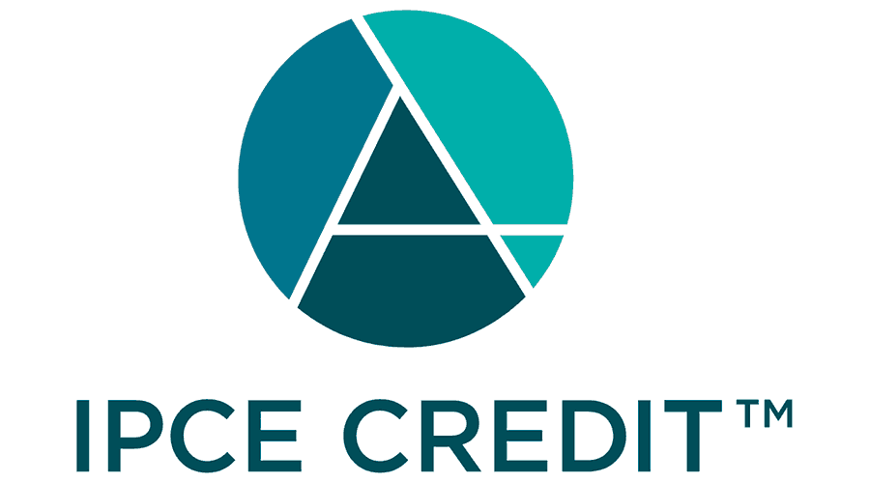

Hours of Participation:
UVA Health Continuing Education awards 7.00 hour(s) of participation (consistent with the designated number of AMA PRA Category 1 Credit(s)TM or ANCC contact hours) to a participant who successfully completes this educational activity. UVA Health Continuing Education maintains a record of participation for six (6) years.

Pharmacists*:
UVA Health Continuing Education has been authorized by the Accreditation Council for Pharmacy Education (ACPE) to award ACPE credit for activities planned in accordance with ACPE Criteria. This knowledge-based activity is designated for 7.00 ACPE credit hour(s).
*DOB and NABP are required for reporting APCE credit











